## Help

Help provides information about default Jumper/Switch settings. Clicking on Default Jumper Setting as shown in Figure 19 will pop-up new window with default Jumper/Switch settings information as shown in Figure 20.

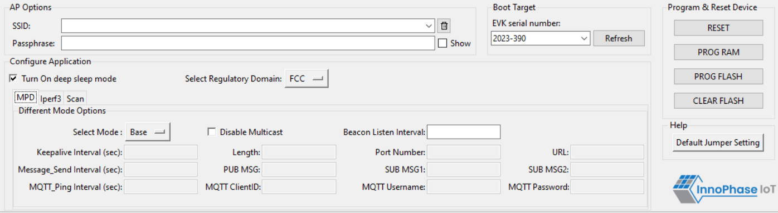

Figure 19: Help Frame

Figure 20: Default Jumper/Switch setting Window

**Note**: Default Jumper/Switch setting window will appear every time when tool is launched, as shown in Figure 21. To turn this feature OFF permanently, check the Do not show again option and close the window.

Figure 21: Default Jumper/Switch setting Window during Tool Launch